Localhost url

http://localhost:3002

Postman Screenshot

createPost API(http://localhost:3002/postsroute/createPost)

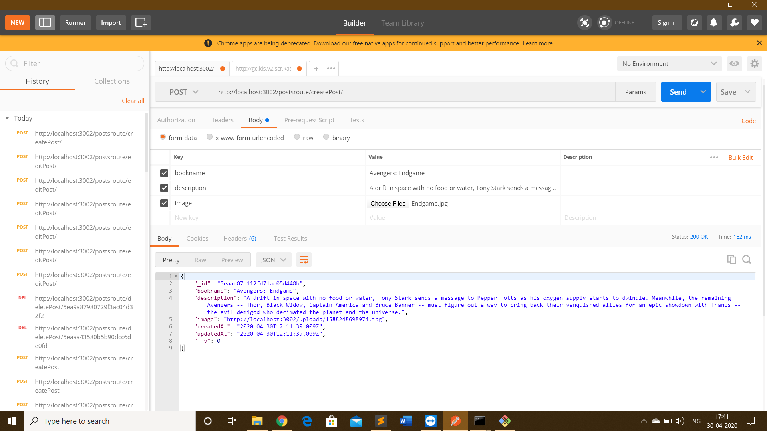

editPost API(http://localhost:3002/postsroute/editPost)

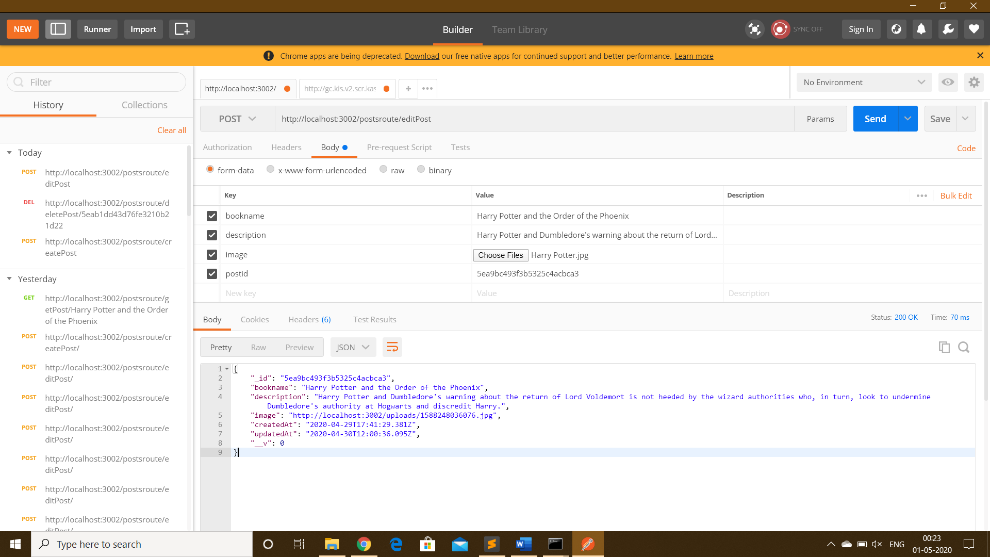

deletePost API(http://localhost:3002/postsroute/deletePost/5eaac07a112fd71ac05d448b)

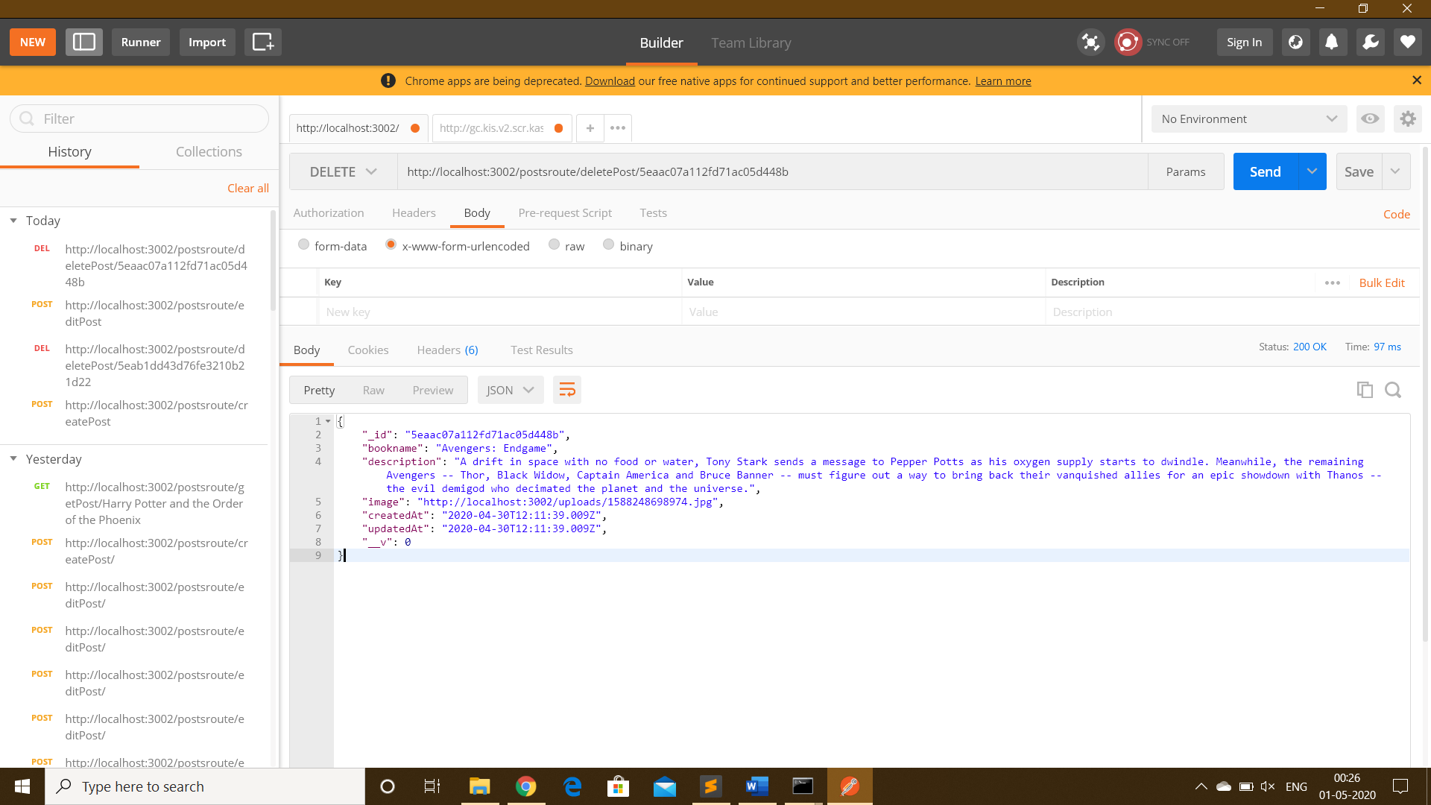

getPost API(http://localhost:3002/postsroute/getPost/Avengers: Endgame)

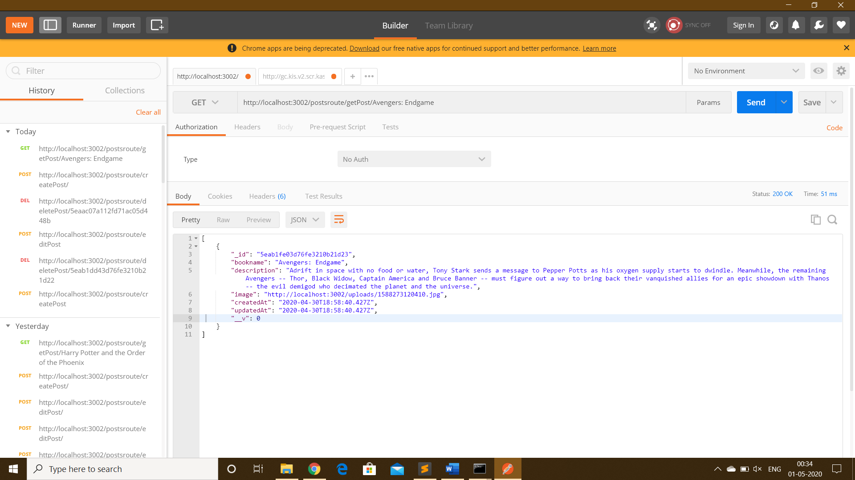

Mongodb

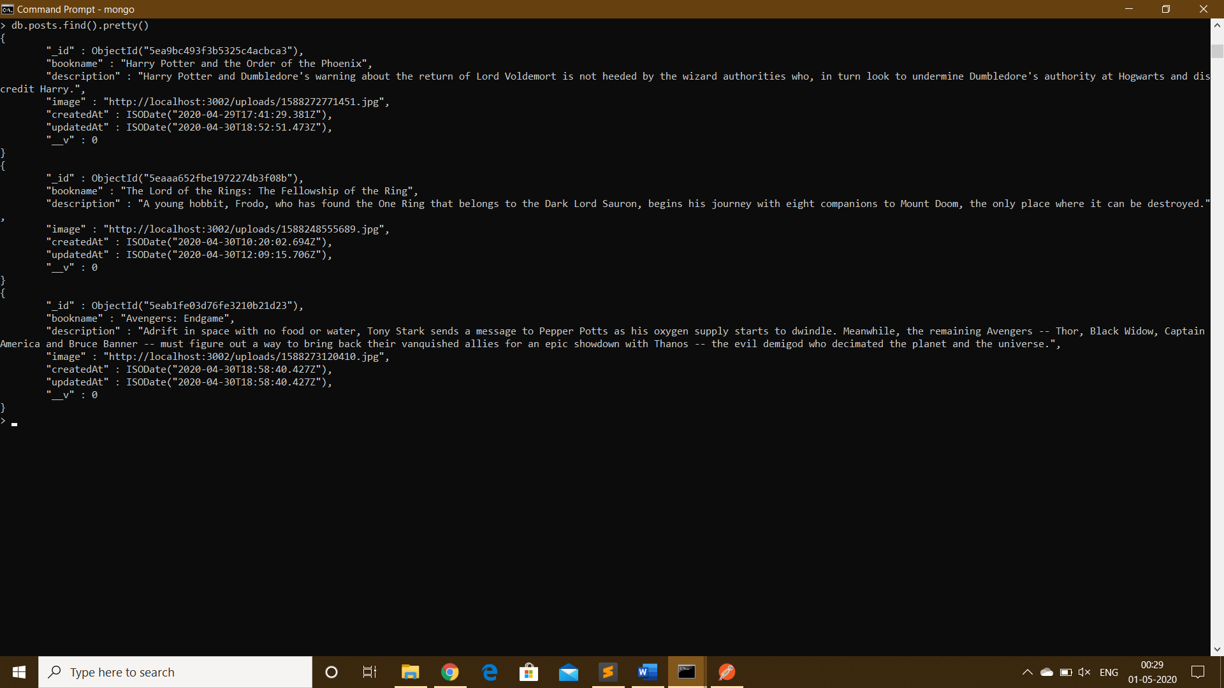

Nodemon

